Comparing Sustainable Development Aid and Need

Isaac Liu

# Abstract

# Introduction

The efficacy of foreign aid, specifically “official development assistance” on the prospects of nations and individuals is a hotly debated question. Sachs, Easterly, and others have noted both the ability of aid to deliver transformative social change, while also outlining serious concerns such as dependency and ulterior motives (J. Sachs 2014). If aid truly is to be most effective, however, of critical importance is the question of its correct allocation. One fair general principle with a relevant and intuitive basis for the evaluation of allocation is that aid should go to countries that have the greatest need for it. For example, in late 2019 the World Bank came under fire for assistance to China, which some argue, as an upper middle income country, did not “need” loans (Runde 2019).

In this paper, I explore any differences between multilateral and bilateral official development assistance allocations and “need” in terms of deficits in performance for the sustainable development goals. There is a history of such analysis for poverty, the Millennium Development Goals, and in fragmented areas of Sustainable Development. Here, however, I examine the current global sustainable development agenda by contributing a systematic analysis.

I make use of newly released data from the OECD’s SDG Financing Lab which uses machine learning to link aid data to SDGs via textual analysis of projects and covers all nations available in the Development Assistance Committee’s Creditor Reporting System from 2012 to 2017. To get a sense of need I use indicators included with the SDGs found in UN and World Bank macro data for a similar time span. These indicators are carefully selected to get a sense of the absolute scale of challenges on an aggregate or population-wide scale.

In terms of data analysis, I begin by computing a mismatch index between shares of aid and need and track this index across years and sectors. Taking a less subjective and ordinal, rather than cardinally robust approach to mismatch I also check a raw ranking of nations. In a regression specification, I check the ability of need to predict aid while also accounting for several other factors behind aid decisions such as the strength of policy and institutions in recipient countries. Finally, I examine cases of notable outliers in terms of situations of large disproportionalities and any potential explanations.

The results provide interesting insight into how funding priorities relate to need. They do not necessarily make a judgement about where aid should go, but instead check the judgement that is already implicitly made. For example, one means of interpretation is that of implied efficiency: if aid allocation is assumed to be optimal, then do donors hold “plausible” beliefs about efficacy?

Discuss results and conclusion further

# Literature Review

A large amount of work has been done on the efficiency of aid to eradicate poverty. Early work was done by Collier and Dollar, who used a series of regressions to determine the effect of aid on growth, and of growth on poverty alleviation under a headcount ratio, average poverty gap, or squared poverty gap (Dollar and Collier 1999). Results suggested that the poverty efficient allocation, accounting for policy and governance, was unambiguously under or over the actual allocation for 52/59 countries, suggesting a large mismatch. Other work focusing on poverty found that ODA per poor person is lowest where poverty is greatest (Improving ODA allocation for a post-2015 world n.d.). The concern for need in a variety of sectors covered in this paper is not the same as that of poverty efficiency based on growth for aid allocations. However, under a reasonable assumption of declining marginal efficacy or impact for aid, the concepts can become quite similar.

Aside from work on poverty, previous work has been done on the relevance of Millennium Development Goals using Tobit models to account for non-linear relationships between indicators and aid in the form of multilateral and bilateral commitments (Thiele, Nunnenkamp, and Dreher 2007). Controls were implemented for per capita income and governance, and systems with population and equal weightings for countries were considered. Out of MDG indicators considered in the areas of hunger, education, health, sanitation, and environment, only undernourishment and HIV/AIDs prevalence were found to influence respective aid allocations.

However, the Millennium Development Goals were seen by some to focus too much on improvements for poor countries, (J. D. Sachs 2012), so in 2015 a broader and more holistic range of priorities in the Sustainable Development Goals was established. Additional goals relative to the SDGs which can now be evaluated include those on growth and infrastructure and institutions, and sustainability considerations have been integrated into other targets. I consider the SDG agenda in a new time period and focus on aid disbursements rather than commitments.

There has also been fragmentary and non-systematic exploration of allocations and need for individual sectors or sustainable development goal areas, with mixed findings. For example, the allocation of food aid (in line with SDG 2 concerning hunger) has been shown to be driven by not just demand, but also supply side factors (Qian and Nunn 2015). Health aid has been found to be responsive to country needs in terms of child and infant mortality and HIV prevalence through a larger number of projects and average aid value by donor (Lee and Lim 2014). A regional analysis of water and sanitation ODA commitments versus the share of global population without improved sources found potential overfinancing in Western Asia and North Africa and potential underfinancing in Central and Southeaster Asia (UN-Water and World Health Organization 2017). Gender gaps in health and education have been found to be associated with larger allocations of aid in those sectors and overall (Dreher, Gehring, and Klasen 2015). In my work I instead try to take a more systematic approach for each of the goals. One key advantage is that of comparability between goals and priorities in terms of the level of matching.

For the sake of transparency and in order to comply with specific normative criteria, some organisations have tried to translate guiding principles into formulae used to rank countries for the purpose of the allocation of aid. The World Bank uses a performance-based allocation (PBA) formula including indicators such as GNI per capita, population size and a measure of the country performance. UNICEF uses a formula that includes the size of the child population and the under-five mortality rate. The European Commission (EC) uses several different formulae combined with various normative criteria to allocate aid funds. These are examples of attempts to operationalise normative criteria, but, in the overall panorama of aid, these criteria remain diverse and organisation specific.

Finally, detached from any particular development goals, past work has also examined bilateral sectoral allocations of aid across the sectors of food, health, humanitarian aid, transport, communications, energy, education, and debt relief from the 1970s to 2000s (Kasuga 2008). Need was determined for each country and sector on a quantile basis with 20 quantiles for performance on World Development Indicators. Recipient aid was found to generally fit recipient needs well using Spearman’s rank coefficients which do not assume that the relationship between aid and need is linear (similar to the check of ranking in this paper). Food, health, and STD control aid were relatively well allocated, but education and debt relief were not. I use updated SDG sectors, cover multilateral aid and more bilateral agencies, and test assumptions more complex than rank ordering over a different time period.

# Data

My main source for data on foreign aid

* + Aid
    - The OECD SDG Financing Lab (The SDG Financing Lab n.d.)
      * Root data source: OECD DAC CRS reporting
        + Guide to usage: <http://www.oecd.org/dac/stats/crsguide.htm> (Technical Guide to terms and data in the Creditor Reporting System (CRS) Aid Activities database - OECD n.d.)
      * The lab has used machine learning (textual analysis) of projects to sort CRS data on aid into SDG areas for numerous countries from 2012-2017 (Linking Aid to the Sustainable Development Goals – a machine learning approach 2019)
        + Additional guidelines for usage: <https://www.oecd-ilibrary.org/development/linking-aid-to-the-sustainable-development-goals-a-machine-learning-approach_4bdaeb8c-en>
        + 76 percent of all CRS projects linked to at least one SDG
      * Addresses multidimensionality of aid with respect to goals aside from simple sectoral allocations in earlier work
      * Focus on official development assistance (from the public sector), as it is the most likely to be influenced by the sustainable development goals and targeted based on need
        + Although oda may have a political motive, private finance is likely to have a profit motive
      * Flows or net aid? Would need to calculate net aid
        + Shouldn’t matter since this is a selection of high income nations
      * There is data on ODA gross disbursements and commitments
        + Better to work on disbursements since this represents the actual amount distributed and commitments are not always achieved, but it would also be easy to switch over to/also check commitments
  + Need
    - The UN Statistics Division lists numerous SDG indicators for each goal (Overview — SDG Indicators n.d.). There is also a database of SDG metrics and series (Measuring progress towards the Sustainable Development Goals - SDG Tracker n.d.).
    - Choose indicators which can be interpreted with mind to following:
    - Principle defining “need”: where possible, use aggregate measures of deficit, a rough benchmark for the economic cost of solving a problem for a country
      * Examples: cost required to solve poverty
      * Population weighting in terms of ratios/rates
      * Scale of the problem
    - ~~Poverty~~
      * ~~SDG 1 (no poverty)~~
      * ~~Top indicators include $1.90 headcount ratio, average poverty gap (particularly useful multiplied by poverty line and population to represent the cost of eradicating poverty with perfect targeting), squared poverty gap, which are all readily available from WBOpenData (World Bank Open Data | Data n.d.)~~
    - ~~Shared Prosperity~~
      * ~~SDGs 8 (decent work and economic growth), 9 (industry, innovation, and infrastructure), 10 (reduced inequalities)~~
      * ~~Candidate indicators include annualized average consumption/income growth for the bottom 40% of the population, income share held by lowest 20%, Gini Indices, Total Unemployment Rate (ILO estimate)- use labor force participation instead? Total number unemployed (World Bank Open Data | Data n.d.)~~
      * ~~Infrastructure~~
    - ~~Sustainability~~
      * ~~SDGs 7 (affordable and clean energy), 11 (sustainable cities and communities), 12 (responsible consumption and production), 13 (climate action), 14 (life below water), 15 (life on land)~~
      * ~~Candidate indicators include Total Greenhouse Gas Emissions (and Per Capita), Renewable Energy Consumption (% of total consumption) (World Bank Open Data | Data n.d.)~~
      * ~~Material footprint per GDP (Indicator 8.4.1 n.d.)~~
    - ~~Check as many goals as time allows, add 2-6, 16, 17. Support on which indicators to choose from by suggested targets for SDGs:~~ [~~https://unstats.un.org/sdgs/indicators/database/~~](https://unstats.un.org/sdgs/indicators/database/)
    - Could be paired with data tracking progress towards goals on indicators to look at efficacy (Measuring progress towards the Sustainable Development Goals - SDG Tracker n.d.)
    - One other notion of “need” on a sectoral basis could be distance from targets in percentage terms (— SDG Indicators n.d.) (certain page number of this report; need to find again)
  + Other Factors (regression controls)
    - Institutions
      * Governance indicators available on WBOpenData (World Bank Open Data | Data n.d.)
    - Democracy
      * Polity IV (PolityProject n.d.)
  + Closest to meeting goals: <https://www.sustainabledevelopment.report/>

Highlighted Indicators have not yet been analyzed, but in all cases obtaining the data and including in analysis would be relatively simple.

Need a tip on a broad gender index with very good availability- UNHDI Gender Index?

|  |  |  |  |
| --- | --- | --- | --- |
| Sustainable Development Goal | Primary Indicator | Other Indicator | Other Indicator |
| SDG 1: No Poverty | Cost to Solve Ext. Poverty with Perfect Targeting | Count of Ext. Poor |  |
| SDG 2: Zero Hunger | Count of Undernourished |  |  |
| SDG 3: Good Health and Well-being | Health Spending Shortfall from High Income Per Capita Levels | Life Expectancy at Birth Shortfall | Maternal, Child Mortality in Number of Deaths |
| SDG 4: Quality Education | Govt Spending on Ed Shortfall from High Inc PC Levels | Count of Illiterate |  |
| SDG 5: Gender Equality | ~~Female participation in decision making~~ | ~~Gap in time spent on unpaid work~~ | Legal Protections/Gender Inequality Indices- UN HDI, WB Women, Business and the Law- 100s of countries, summary indicator, data series from 1970s |
| SDG 6: Clean Water and Sanitation | Population Without Safely Managed Drinking Water | Population Without Safely Managed Sanitation |  |
| SDG 7: Affordable and Clean Energy | Population Without Access to Electricity |  |  |
| SDG 8: Decent Work and Economic Growth | Number of Unemployed (ILO) | ~~GDP Per Capita Growth~~ |  |
| SDG 9: Industry, Innovation and Infrastructure | Investment in Transport Shortfall from High Income Per Capita Levels | Investment in Energy Shortfall from High Income Per Capita Levels |  |
| SDG 10: Reduced Inequality | Gini Index |  |  |
| SDG 11: Sustainable Cities and Communities | Urban Population in Slums | Economic Loss due to Disasters |  |
| SDG 12: [Responsible Consumption and Production](http://www.un.org/development/desa/disabilities/envision2030-goal12.html) | Emissions per GDP |  |  |
| SDG 13: Climate Action | Renewable Energy Share of Total Electricity Output |  |  |
| SDG 14: Life Below Water | Percent Marine Protected Areas Shortfall from High Inc PC Levels |  |  |
| SDG 15: Life on Land | Percent Terrestrial Protected Areas Shortfall from High Inc PC Levels (or land area itself) |  |  |
| SDG 16: Peace and Justice Strong Institutions | Internally Displaced Persons by Violence | WGI Public Sector and Institutions Index |  |
| SDG 17: Partnerships to achieve the Goals | Domestic Resource Mobilization Index/Efficiency of Revenue Mobilization Score | Statistical Capacity Score |  |

Do not necessarily match UN Indicators but often derived from them

UN as an equal sovereignty not population weighted body

Some summary statistics, notably on the number of observations available.

* Aid observations available from about 130-150 countries for all years and sectors
* Basics such as GDP, population needed for other calculations have similar availability
* Poverty observations around 40 countries every year
* Gender- very few observations
  + Problem- expect naturally large mismatches, demonstrate with normal distribution draws- very poor fit to true levels, lots of variation

Also do sum stats in long form to get easier overall trends.

Full table of summary statistics available as an appendix.

# Methodology & Results

The first measure of the relationship between aid and “need” that I present is that of a mean mismatch index.

* + - Compare shares of aid and shares of need for all countries
    - For each indicator and year, compute over all countries
 $Mean(|Share of deficit in need-Share of deficit in indicator|)$

   - * Absolute deviation
      * Also calculate net deviation with parentheses, not absolute value
      * And squared deviation to weigh larger deviations more.
  + Discuss the data issue of making shares among those for which info on both need and aid are available.
    - ~~Large country: probably a large share of aid and large share of deficit, hence heavier weighting~~
      * ~~Try equal weighting for each country versus population/share weighting above? The absolute value difference as a percentage of share of deficit or share of aid: divide each sum term by share of deficit or aid~~
      * ~~Multiply deficit back times something to get the total dollar amount needed for a correction?~~
    - I originally dealt with sums, but then switched to means for interpretability and far better treatment of missing values

The graphs below depict the mean mismatch measure (using absolute values) for the 27 indicators initially considered across all countries over time. Missing data is excluded. The graphs appear blank for the indicators of transport financing gap (from rich country averages) and urban slum populations due to a lack of connected data points. (At some point, I plan on correcting this issue.)

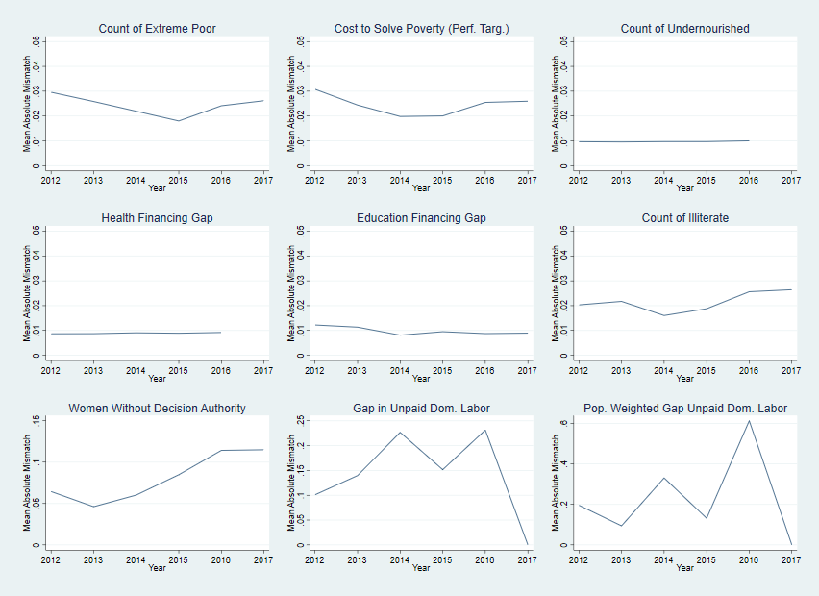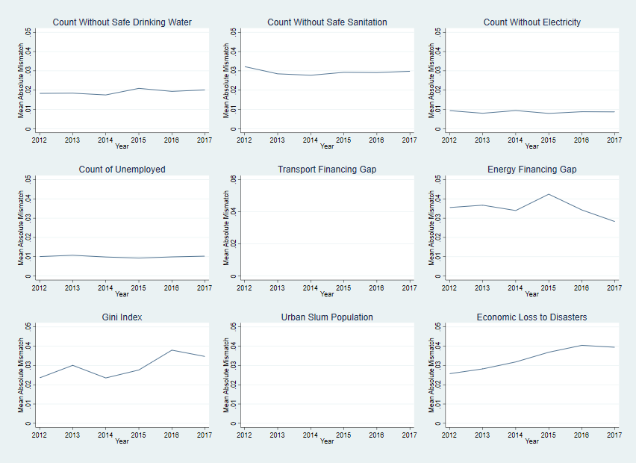

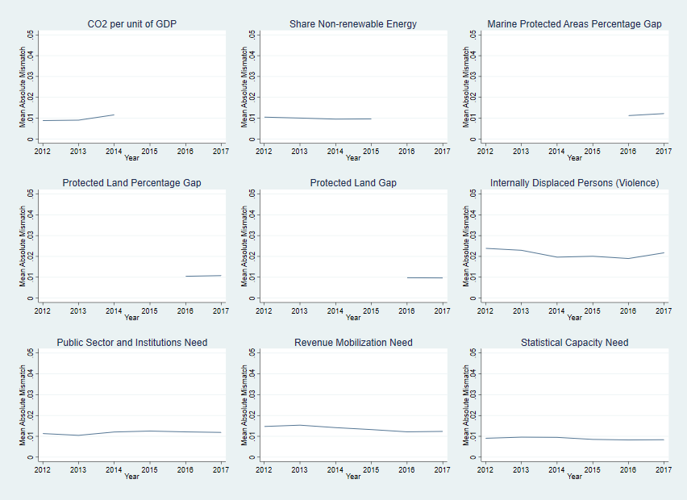

Mean absolute mismatch is particularly high for certain indicators. Of note is the particularly poor fit between aid and need for the three gender indicators: the share of women without decision making authority on three critical domains in the household, and the gap in the amount of time spent on tasks between men and women (in raw terms and weighted by population). In all cases, mean mismatch is several times higher than for non-gendered indicators. A possible explanation may be the fact that gender inequality is likely referenced as a secondary, rather than primary goal for ODA funded programs. It could be the fact that nations with high levels of gender inequality are not inclined to accept programs or foreign aid aimed towards reducing it. The wide level of variation seen is likely driven by data availability issues for certain years. After re-examining summary statistics, it appears gender data is available usually for less than a dozen countries. Check relation of mismatch and number of observations across indicators.

Aside from the gender indicators, three clear classes of fit appear to emerge. Indicators with a mean absolute mismatch of above or around three percent include numbers of individuals without safe sanitation, energy (infrastructure) financing gaps from rich country levels, the Gini index is recent years, and economic loss to disasters (particularly in recent years). Sanitation may be a less salient and politically attractive goal compared to drinking water, which leads to a poorer fit. The energy financing indicator notably includes private sector investment, which may not form as good of a fit as public spending. The Gini index is rather difficult to conceptualize as a target for aid funding- inequality may be seen as an internal political issue. Mismatch on loss due to disasters appears to be rising overtime, a concerning trend, although this may be the product of fairly poor data availability.

More indicators form a next class, with absolute mismatch around two percentage points. For both poverty indicators, the count of extreme poor and cost to solve poverty, mismatch fell to around two percent in 2015, the year of passage for the sustainable development agenda, but has since increased back to around three percent, perhaps suggesting shifting priorities.

Last class- very good fit such as food/undernourished, health, ed, governance indicators.

Continue describing results…

The mismatch index displays

Minimum and maximum mismatch

The extremely large mismatch values for gender indicators probably drive extreme behavior in 2014 and 2016 (I will try this again while dropping the gender indicators). Aside from these events, mean levels of about three percent seem to be persistent for all countries. ~~Better interpret the size of this in dollar terms?~~ Choose primary indicators only, or perhaps choose indicators with the best fit- test assumptions. Or just weight each goal equally- so average across infrasturcure indicators and make this 1/17.

* Raw ranking: order countries by aid and by need
  + - Spearman’s rank coefficient?
    - Co2 per GDP about 0
    - Cost to solve poverty consistently above 0.5, reached even 0.79 in 2013
    - Education financing gap 0.7 to 0.8
    - Graph rank coefficients? (Line) Or create a table.
    - Follow the country and see changes in position- bump graphs, more interpretable
      * Look off of regression or mismatch results for these graphs
  + Regression and controls
    - Test model predicting foreign aid based on need (share of indicator deficit)
    - Consider using country and year fixed effects since there is panel data
    - For each indicator, country i, year t

*Share of Aidit = ai + at + b(Share of Need/Deficit)it+ c(Controls)it + eit*

* + - Include controls for democracy, institutions
    - Include (if available) control for any other factors informing “efficacy”
    - Include interaction terms
    - Try nonlinear models: logs, tobits
    - Try just regressing aid on indicator/deficit
      * Sensitive to weighing countries by population or equally
    - Notable Significant regression results
    - Energy financing gaps from rich country levels- extremely significant and positive relationship between aid share and need share, especially with time and country fixed effects. In this linear model,

|  |  |  |  |
| --- | --- | --- | --- |
|  | (1) | (2) | (3) |
|  | aisEnfinGap | aisEnfinGap | aisEnfinGap |
| nsEnfinGap | 0.0980** | 0.0904* | 0.0870*** |
|  | (3.04) | (2.47) | (5.18) |
|  |  |  |  |
| polity2 |  | -0.000582 | 0.000481 |
|  |  | (-1.29) | (1.71) |
|  |  |  |  |
| _cons | 0.0121*** | 0.0151*** | 0.0103*** |
|  | (9.38) | (4.85) | (6.89) |
| *N* | 202 | 197 | 197 |

*t* statistics in parentheses

* *p* < 0.05, ** *p* < 0.01, *** *p* < 0.001

* + - Poverty headcount, before fixed effects included- perhaps fluke of data availability as panel is not of good quality (nature of HH budget surveys in only being in several years

|  |  |  |  |
| --- | --- | --- | --- |
|  | (1) | (2) | (3) |
|  | aisextPoorCt | aisextPoorCt | aisextPoorCt |
| nsextPoorCt | 0.0951*** | 0.0898*** | -0.0332 |
|  | (3.81) | (3.48) | (-1.24) |
|  |  |  |  |
| polity2 |  | -0.000316 | -0.00190 |
|  |  | (-1.36) | (-1.57) |
|  |  |  |  |
| _cons | 0.00437*** | 0.00600*** | 0.0167** |
|  | (5.54) | (3.34) | (2.77) |
| *N* | 259 | 251 | 251 |

*t* statistics in parentheses

* *p* < 0.05, ** *p* < 0.01, *** *p* < 0.001

* + - Food aid and undernourishment- food aid shows itself to be very well allocated

|  |  |  |  |
| --- | --- | --- | --- |
|  | (1) | (2) | (3) |
|  | aisSN_ITK_DEFCN | aisSN_ITK_DEFCN | aisSN_ITK_DEFCN |
| nsSN_ITK_DEFCN | 0.0768*** | 0.0709*** | 0.323** |
|  | (4.53) | (4.32) | (2.67) |
|  |  |  |  |
| polity2 |  | -0.000225* | -0.000569 |
|  |  | (-2.46) | (-1.14) |
|  |  |  |  |
| _cons | 0.00650*** | 0.00776*** | 0.00652*** |
|  | (15.31) | (11.97) | (3.51) |
| *N* | 567 | 512 | 512 |

*t* statistics in parentheses

* *p* < 0.05, ** *p* < 0.01, *** *p* < 0.001

* + - Disaster aid- gains some signficince with fixed effects but very small coefficient

|  |  |  |  |
| --- | --- | --- | --- |
|  | (1) | (2) | (3) |
|  | aisVC_DSR_GDPLS | aisVC_DSR_GDPLS | aisVC_DSR_GDPLS |
| nsVC_DSR_GDPLS | 0.00360 | 0.00292 | 0.00924* |
|  | (1.25) | (0.98) | (2.38) |
|  |  |  |  |
| polity2 |  | -0.00000518 | 0.000160 |
|  |  | (-0.04) | (1.18) |
|  |  |  |  |
| _cons | 0.00600*** | 0.00643*** | 0.00550*** |
|  | (9.67) | (7.03) | (8.37) |
| *N* | 314 | 294 | 294 |

*t* statistics in parentheses

* *p* < 0.05, ** *p* < 0.01, *** *p* < 0.001

* + - IDPs- dramatically loses significance with country and time fixed effects

|  |  |  |  |
| --- | --- | --- | --- |
|  | (1) | (2) | (3) |
|  | aisvc_idp_tocv | aisvc_idp_tocv | aisvc_idp_tocv |
| nsvc_idp_tocv | 0.138*** | 0.150*** | -0.0525 |
|  | (6.83) | (8.38) | (-0.61) |
|  |  |  |  |
| polity2 |  | 0.000430** | 0.000245 |
|  |  | (2.86) | (0.93) |
|  |  |  |  |
| _cons | 0.0121*** | 0.00937*** | 0.0142*** |
|  | (10.40) | (7.69) | (8.51) |
| *N* | 301 | 280 | 280 |

*t* statistics in parentheses

* *p* < 0.05, ** *p* < 0.01, *** *p* < 0.001

* + - Notable other regression results
    - No electricity- significant and large positive relation that turns to a very large negative relation considering time and country fixed effects. Only indicator so far with democracy as a significant variable

|  |  |  |  |
| --- | --- | --- | --- |
|  | (1) | (2) | (3) |
|  | aisnoElec | aisnoElec | aisnoElec |
| nsnoElec | 0.315*** | 0.306*** | -0.282*** |
|  | (8.56) | (8.43) | (-3.76) |
|  |  |  |  |
| polity2 |  | -0.000229 | 0.000318* |
|  |  | (-1.84) | (2.30) |
|  |  |  |  |
| _cons | 0.00504*** | 0.00663*** | 0.00982*** |
|  | (9.80) | (7.30) | (13.44) |
| *N* | 814 | 687 | 687 |

*t* statistics in parentheses

* *p* < 0.05, ** *p* < 0.01, *** *p* < 0.001

* Public sector quality/institutions aid- very large OLS significance, which disappears with fixed effects. Institutions matter, especially for aid to those institutions

|  |  |  |  |
| --- | --- | --- | --- |
|  | (1) | (2) | (3) |
|  | aisNPSI | aisNPSI | aisNPSI |
| nsNPSI | 1.170*** | 0.886*** | 0.386 |
|  | (4.44) | (3.92) | (0.73) |
|  |  |  |  |
| polity2 |  | 0.000133 | 0.000369 |
|  |  | (1.24) | (1.75) |
|  |  |  |  |
| _cons | -0.00694* | -0.00324 | 0.00279 |
|  | (-2.54) | (-1.36) | (0.39) |
| *N* | 460 | 370 | 370 |

*t* statistics in parentheses

* *p* < 0.05, ** *p* < 0.01, *** *p* < 0.001

* Climate aid and share of elec from non renewables is not at all significant, despite large sample size. Perhaps very concerning.

|  |  |  |  |
| --- | --- | --- | --- |
|  | (1) | (2) | (3) |
|  | aisNRenShare | aisNRenShare | aisNRenShare |
| nsNRenShare | 0.128 | 0.0179 | -0.354 |
|  | (1.40) | (0.17) | (-0.74) |
|  |  |  |  |
| polity2 |  | 0.000120 | 0.000967 |
|  |  | (0.53) | (1.15) |
|  |  |  |  |
| _cons | 0.00630*** | 0.00786*** | 0.00814 |
|  | (6.14) | (5.56) | (1.53) |
| *N* | 554 | 460 | 460 |

*t* statistics in parentheses

* *p* < 0.05, ** *p* < 0.01, *** *p* < 0.001

* Protected lands gap from rich country levels- not at all significant as a percentage, but significant and large in terms of actual land area.

|  |  |  |  |
| --- | --- | --- | --- |
|  | (1) | (2) | (3) |
|  | aisPLandPGap | aisPLandPGap | aisPLandPGap |
| nsPLandPGap | -0.230 | -0.300 | 0.206 |
|  | (-1.60) | (-1.82) | (0.44) |
|  |  |  |  |
| polity2 |  | -0.000108 | 0.000133 |
|  |  | (-0.52) | (1.96) |
|  |  |  |  |
| _cons | 0.00903*** | 0.0109*** | 0.00651 |
|  | (6.14) | (5.86) | (1.92) |
| *N* | 269 | 233 | 233 |

*t* statistics in parentheses

* *p* < 0.05, ** *p* < 0.01, *** *p* < 0.001

|  |  |  |  |
| --- | --- | --- | --- |
|  | (1) | (2) | (3) |
|  | aisPLandGap | aisPLandGap | aisPLandGap |
| nsPLandGap | 0.228* | 0.205* | 0.523* |
|  | (2.48) | (2.16) | (2.41) |
|  |  |  |  |
| polity2 |  | 0.0000336 | 0.000136* |
|  |  | (0.16) | (2.03) |
|  |  |  |  |
| _cons | 0.00575*** | 0.00666*** | 0.00357 |
|  | (6.23) | (4.80) | (1.88) |
| *N* | 265 | 229 | 229 |

*t* statistics in parentheses

* *p* < 0.05, ** *p* < 0.01, *** *p* < 0.001

Unemployment and decent work/infrastructure aid- somewhat significant before fixed effects

|  |  |  |  |
| --- | --- | --- | --- |
|  | (1) | (2) | (3) |
|  | aisunemployedCt | aisunemployedCt | aisunemployedCt |
| nsunemployedCt | 0.0791* | 0.0748* | 0.132 |
|  | (2.44) | (2.34) | (0.67) |
|  |  |  |  |
| polity2 |  | -0.0000264 | -0.000860 |
|  |  | (-0.18) | (-1.00) |
|  |  |  |  |
| _cons | 0.00713*** | 0.00763*** | 0.00983** |
|  | (10.25) | (7.21) | (2.84) |
| *N* | 766 | 690 | 690 |

*t* statistics in parentheses

* *p* < 0.05, ** *p* < 0.01, *** *p* < 0.001

* Discuss disproportionate country and sector pairs
  + Point out specific cases where implied need and aid vary to a large degree
  + Implied efficiency: Under an assumption of optimal allocation, what is the implied relative marginal benefit, and is it plausible
  + For example, assume India has a poverty share of 20% but only receives 10% of poverty reduction aid. If there is an optimal allocation, is it assumed every dollar is twice as effective in India? Is this plausible as the optimum allocation/difference in efficiency?
  + Absolute mismatches larger than 10%
    - Egypt, CO2 and climate aid in 2012 and 2014. Tremendous shares of aid, but very low shares of need (practically zero percent). Emissions per GDP are very low, but millions/billions dispensed. Arab Spring?
    - Cost to solve poverty- Brazil, 17% of need worldwide, but almost no aid (zero percent-ish). Similar statistics for China, almost a quarter of costs. Middle income countries with large populations tend to be ignored. These are BRICS nations sometimes considered to be advanced in terms of development, perhaps capable of mobilizing domestic resources. But the trend may also fall in the other direction from some middle-income nations: Colombia received 20% of aid in 2014, but only had about 2% of need. The DRC saw a massive disparity in 2012, possessing 34% of need but receiving only 2% of aid- institutional characteristics are likely to have played a key factor in this situation. In 2012 Ghana received nearly 20% of aid among the countries counted but possesses about 1% of need, and a similar case applied for Vietnam; for Malawi the and Uganda the reverse is true. Pakistan and Turkey, strategically important allies for certain nations receives tremendous shares despite very few extreme poor. In 2017, Tanzania made up nearly half of all need but received only about a quarter of aid.
      * In sum- much disparity in the middle income. Perhaps donor behavior has not yet adjusted to the new middle income status of these nations.
    - Practically the same results hold for poverty headcounts, although Indonesia also emerges as an underfinanced nation. Except for 2013, when it received 10% of aid on about 20% of need, the gap is often extremely large, with receipts of only a few percent of aid for around 20% of the global headcount of covered nations in 2016 and 2017.
    - Education financing- India in 2012/2013 was about half of all ed shortfall worldwide, yet received 3-5% of aid.
    - Energy financing gaps- Large populations in China and India suggest persistently large need shares in 30-40% terms. China receives almost no energy aid; India receives between 5 and 10 percent of the global cut. Morocco, Turkey, and Vietnam all received large chunks of energy finance (10-20%) despite almost no need; in fact, the first two spent about as much per capita as high income nations.
    - Health- India and China largely underfinanced
* Discuss disproportionate sectors and countries in aggregate
* Disproportionality in terms of size relative to own shares- to remove so much large country bias in coverage here.
* Discuss overall allocation among countries and sectors
  + Which sectors receive the most funding, particularly relative to progress towards targets- is something revealed about preference or relative importance of goals
* Analysis for countries by year across all indicators (see end of dofile)
* Analyze before/after sustainable development goals era: was there a change in priorities or allocations, or fit

# Conclusion

As is present in most analyses of aid, there is the caveat of potential reverse causality. It could be that aid leads to significant improvements on sustainable development indicators; “misallocations” to countries with little need are tremendous success stories. The time scales involved in such an interpretation and analysis of what we know about the efficacy of aid make such an explanation seem less plausible; an immediate (within a year) and large impact does not seem likely, but here I leave the causal statistical analysis to rule out such a story completely to other work using instrumental variables and other methods.

Aid is set by country and then by sector? <https://papers.ssrn.com/sol3/papers.cfm?abstract_id=3053363>

Fungibility is expected to be limited in this approach, as sectoral allocations matter

Explaining deviations from need:

Aside from just being a complement of policy in terms of having an impact, aid may be used as a reward to encourage good policy (Collier and Dollar 2004). Multilateral aid may be allocated based on shortfalls of domestic resources, a sense of need not based on just the scope of the problem, but also on capabilities, although previous examinations show poor fit to this purpose (Ceriani and Verme 2014; Maizels and Nissanke 1984). Bilateral aid is often not dispersed according to need, but rather according to political and strategic considerations (Alesina and Dollar 1998).

SDGS for rich and poor countries; but aid not for rich and poor countries?

~~A different stream of the literature (Cogneau & Naudet, 2007; Llavador & Roemer, 2001) focuses instead on equal opportunities. These authors believe that the distribution of aid should equalize opportunities among recipient countries for achieving growth, controlling for the effort undertaken to turn aid into economic growth. This is based on the inequality of opportunities approach, where one should distinguish between circumstances and efforts and try to give a premium to efforts. This approach emphasises the role of equity and became very popular with the steady growth of the inequalities of opportunities literature over the past decade. However, the measurement of inequalities of opportunities mostly relies on household survey data and remains difficult to operationalise for the purpose of aid allocation.~~

* Not very clear impact of passage of SDGs on allocation fit?
* Implications
* Directions for future research

Bibliography

‘— SDG Indicators’. https://unstats.un.org/sdgs/report/2019/ (January 28, 2020).

Alesina, Alberto, and David Dollar. 1998. *Who Gives Foreign Aid to Whom and Why?* Cambridge, MA: National Bureau of Economic Research. http://www.nber.org/papers/w6612.pdf (January 28, 2020).

Beynon, Jonathan. 2003. *Poverty Efficient Aid Allocations: Collier/Dollar Revisited*. London: Overseas Development Institute.

Collier, Paul, and David Dollar. 2004. ‘Development Effectiveness: What Have We Learnt?’ *The Economic Journal* 114(496): F244–71.

Dollar, David, and Paul Collier. 1999. *Aid Allocation and Poverty Reduction*. Rochester, NY: Social Science Research Network. SSRN Scholarly Paper. https://papers.ssrn.com/abstract=629108 (January 29, 2020).

Dreher, Axel, Kai Gehring, and Stephan Klasen. 2015. ‘Gesture Politics or Real Commitment? Gender Inequality and the Allocation of Aid’. *World Development* 70: 464–80.

‘Improving ODA Allocation for a Post-2015 World’. *Development Initiatives*. http://devinit.org/publications/improvingoda2015/ (January 29, 2020).

‘Indicator 8.4.1: Material Footprint per Unit of GDP, by Type of Raw Material (Kilograms per Constant 2005 United States Dollar)’. https://unstats-undesa.opendata.arcgis.com/datasets/9c33807e2ddf4e348737fab085de0ac1_0 (January 29, 2020).

Kasuga, Hidefumi. 2008. ‘Aid Allocation across Sectors: Does Aid Fit Well with Recipients’ Development Priorities?’ : 35.

Lee, Suejin A., and Jae-Young Lim. 2014. ‘Does International Health Aid Follow Recipients’ Needs? Extensive and Intensive Margins of Health Aid Allocation’. *World Development* 64: 104–20.

*Linking Aid to the Sustainable Development Goals – a Machine Learning Approach*. 2019. . OECD Development Co-operation Working Papers. https://www.oecd-ilibrary.org/development/linking-aid-to-the-sustainable-development-goals-a-machine-learning-approach_4bdaeb8c-en (February 20, 2020).

Maizels, Alfred, and Machiko K. Nissanke. 1984. ‘Motivations for Aid to Developing Countries’. *World Development* 12(9): 879–900.

‘Measuring Progress towards the Sustainable Development Goals - SDG Tracker’. *Our World in Data*. https://sdg-tracker.org/ (January 28, 2020).

‘Overview — SDG Indicators’. https://unstats.un.org/sdgs/report/2019/Overview/ (January 28, 2020).

‘PolityProject’. https://www.systemicpeace.org/polityproject.html (January 11, 2020).

Qian, Nancy, and Nathan Nunn. 2015. ‘The Determinants of Food Aid Provisions to Africa and the Developing World’. *ResearchGate*. https://www.researchgate.net/publication/228303877_The_Determinants_of_Food_Aid_Provisions_to_Africa_and_the_Developing_World (February 18, 2020).

Runde, Daniel. 2019. ‘China Doesn’t Need World Bank’s Loans, Just as Trump Says’. *TheHill*. https://thehill.com/opinion/finance/474101-china-doesnt-need-world-banks-loans-just-as-trump-says (February 22, 2020).

Sachs, Jeffrey. 2014. ‘The Case for Aid – Foreign Policy’. https://foreignpolicy.com/2014/01/21/the-case-for-aid/ (February 22, 2020).

Sachs, Jeffrey D. 2012. ‘From Millennium Development Goals to Sustainable Development Goals’. *The Lancet* 379(9832): 2206–11.

‘Technical Guide to Terms and Data in the Creditor Reporting System (CRS) Aid Activities Database - OECD’. http://www.oecd.org/dac/stats/crsguide.htm (February 18, 2020).

‘The SDG Financing Lab’. https://sdg-financing-lab.oecd.org/explore?country=All%20Recipients&distribution=recipients&finance=commitment&from=2012&oda=true&oof=false&other%20private%20flows=false&private%20grants=false&target=All%20providers&to=2017 (February 20, 2020).

Thiele, Rainer, Peter Nunnenkamp, and Axel Dreher. 2007. ‘Do Donors Target Aid in Line with the Millennium Development Goals? A Sector Perspective of Aid Allocation’. *Review of World Economics* 143(4): 596–630.

UN-Water, and World Health Organization. 2017. *Financing Universal Water, Sanitation and Hygiene under the Sustainable Development Goals: UN-Water Global Analysis and Assessment of Sanitation and Drinking-Water : GLAAS 2017 Report.* http://apps.who.int/iris/bitstream/10665/254999/1/9789241512190-eng.pdf?ua=1 (February 22, 2020).

‘World Bank Open Data | Data’. https://data.worldbank.org/ (January 28, 2020).